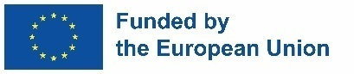
To: Municipality of Aerodrom

APPLICATION FORM FOR RECEIVING THE TENDER DOSSIER
for participating in the procurement of
Supply of a set of household waste selections bags

Basic information for Tenderer

Full name of the Tenderer
Address
Phone
Unique ID number
Code of activity and business | (provide description)
Founder
Manager
Contact person
Mobile phone number
Е-mail where the tender dossier should be sent

Data and Place, Applicant
__________________________ /stamp/ ___________________________

To receive the electronic version of the whole tender dossier, please sent the scanned Application form stamped and signed on the following e-mail: cleanairdrom@aerodrom.gov.mk

Please be informed that the submission of Application Form does not mean that your legal entity has applied for this tender! Only complete tender submitted as according to the criteria set in tender dossier will be further on evaluated!

